Name: ____________________________________Date: ___________________Class______
Toxicology Unit Review Sheet
- Drugs often mimic the action of chemical messengers called _____________________ within the brain.
- Why are teenagers more likely to become addicted to a substance than adults?
- Label the following areas of the brain: cerebrum, cerebellum, midbrain, medulla, & pons
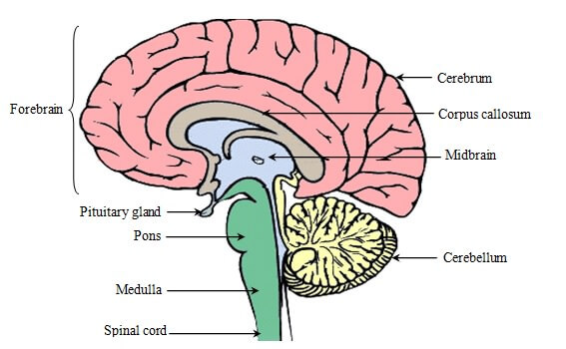
What does the acronym BAC stand for?
- A 160 female who consumes 4 drinks in 3 hours will have a BAC __________ than a male of the same size who consumes the same amount.
- 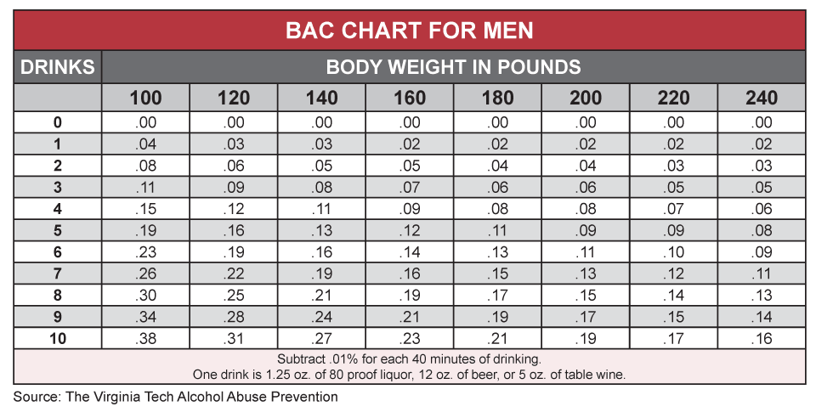

Time Factor Table
Hours Since First Drink: 1 2 3 4 5 6 7 8

Subtract from BAC: .015 .030 .045 .060 .075 .090 .105 .120

If a 180 lb male consumes 7 drinks, will he be legal to drive in Georgia after 4 hours? Show your work and Explain your answer.

- Schedule _____ drugs have the greatest potential for abuse and no medical use whereas the schedule _____ drugs are considered safe and medically useful.
- Drug test that are color test are considered to be ___________________. What do these test tell us?

- Classify the following drugs according to their type:
  - Marijuana b. alcohol
  - Cocaine e. heroin

- How much of the evidence sent to the crime lab is drug-related?
- List two confirmatory tests for drugs. _________________________ & __________________________
- Give two examples of “club drugs” _____________________________ & __________________________
- Give one example of a toxin.
- Give three examples of earliest poisoning uses/cases.
- The deposits of poisons seen in fingernails are called ________________________.
- What would an LD50 of 80 mg/kg indicated about a poison?

- At what BAC is alcohol considered to be lethal?
- Most poisons are categorized as strong ________________ or ____________________.
- Categorize the poisoning from the following substances based on the exposure level:

  - Carbon monoxide __________________
  - Salmonella _______________________
  - Dimethlymercury __________________
  - Polonium-210 _____________________

- Explain the job of a “food taster”.

- What is the relationship of the FDA, EPA, DOT, & OSHA to toxicology?

- In the event of a suspicious death, what are 3 body fluids that toxicology testing may be conducted on?

- Other than body fluids what other two body tissues may carry evidence of poisoning?

A. B. C.
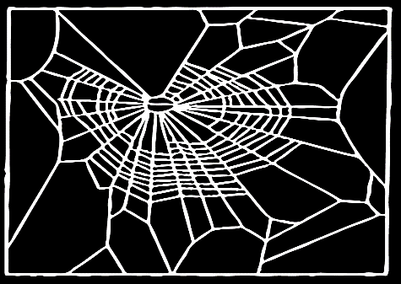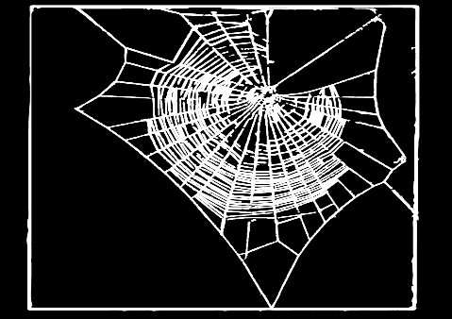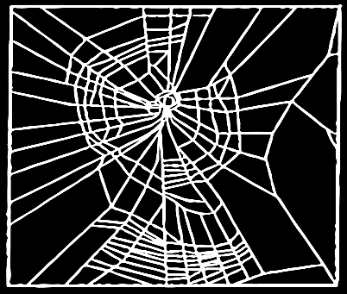

D. E. F.
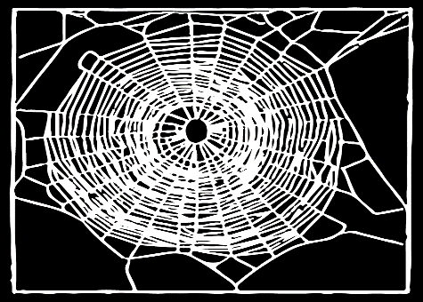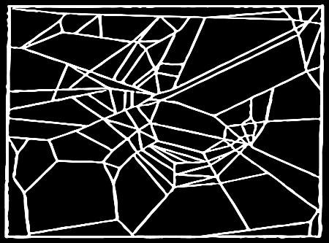
Which web was created by a spider under the influence of :
Morphine _________ Sleeping pills ________ Amphetamines _____________
Caffeine _______ Marijuana _________ NO DRUGS _______

