Name: ___________________________________________Date: _________________Class: ______
Ballistics Review Guide

Word Blank: Fill in the blank using the word bank below.

Antimony
ATF&E
Barium
Class
Energy
FBI
Firing pin
Gravity
Grooves
Headstamp
Individualized
Internal
Lands
NIBIN
Rifling
Striations
Terminal
Trajectory

- Bullets can be individualized to a handgun or rifle by the ______________ which are produced from _______________ (the __________ and ____________) in the barrel.
- While cartridge cases can be individualized by marks left by the ______________ _________.
- The current database for ballistics information is known as ____________________. This database is a collaboration between the ______________ and the _________________.
- The number of lands and grooves are _____________________evidence and striations are __________________ evidence.
- Gunpowder residue is usually identified by the presence of the elements ________________ & __________________.
- A projectile leaves it source of ________________ and is only affected by ______________.
- The path of a projectile is the ______________________.
- ___________________ ballistics studies how a projectile behaves with it encounters a target.
- ____________________ ballistics studies what occurs to the bullet while it is still inside of the gun.
- The end of the cartridge case is known as the ___________________________.

True of False
______ 1. A bullet is an example of a projectile.
______ 2. A rifle is an example of a handgun.
______ 3. The end of a gun barrel is known as the muzzle.
______ 4. Gauge and caliber are the same characteristic of a firearm.
______ 5. Most cartridge cases are rimfire.
______ 6. A rifle can shot both a bullet and a shotgun shell.
______ 7. A land is the raised section of a gun barrel.
______ 8. Gunpowder was discovered by the ancient Greeks.
______ 9. The purpose of rifling is to individualize a gun.
______ 10. A compound microscope is used to compare a test bullet to a crime scene bullet.

Matching: Match the correct definition to the term
______ 1. Caliber a. result of gravity
______ 2. Cartridge Case b. a type of propellant in ammunition
______ 3. Griess Test c. a firearm with a smooth bore barrel
______ 4. Gunpowder d. the diameter of a gun barrel
______ 5. Hammer e. a test for gunshot residue
______ 6. Kinetic Energy f. a pistol with a revolving ammunition chamber
______ 7. Muzzle Velocity g. the container for the primer, propellant and bullet
______ 8. Projectile Drop h. the speed at which a bullet leaves the gun
______ 9. Revolver i. energy of motion
______ 10. Shotgun j. strikes the firing pin
Short Answer
- A bullet is recovered at a crime scene and a gun is found nearby. Explain the process for determining if this bullet was fired from that particular firearm?

- Explain why there is a flash at the end of the gun barrel when the gun is fired.

- Describe what happens to a bullet when it encounters a target.

- What is the relationship between the trajectory of a bullet and the path of that same bullet as it moves through a victim’s body?

- Explain how to differentiate between the results of a bullet fired at 6 inches from the victim to a bullet fired at 24 inches from the victim.

- What two areas of a shooter’s hand should be tested for gunshot residue (GSR) and why?

- Explain how to collect firearm evidence from a crime scene.

Diagrams – Label the handgun components A-G

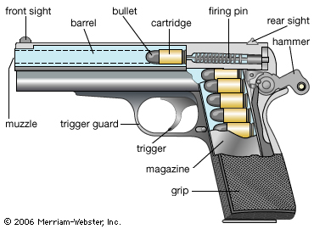
A.
B
E
F
C D

G

Label the lands and the grooves. Indicate if the bullet has a right or left twist.

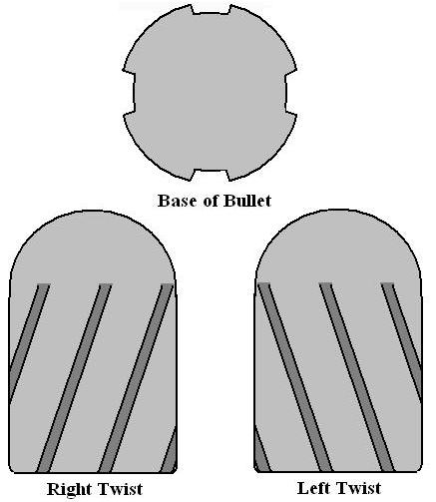

Label the type of ammunition and the numbered components.

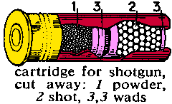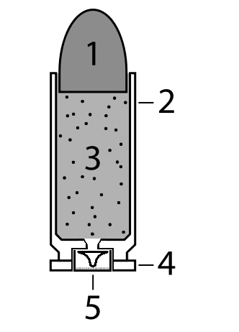

Complete the Data Table

Traits | Entry Wound | Exit Wound
Size
Margin
Singeing, Burning, Blackening and Tattooing
Blood Loss

JFK Assassination

- ______________________ is believed to be the assassin of JFK.
- The assassination occurred in _________________________.
- T or F JFK was the only person shot.
- Summarize the two predominate theories about the assassination of JFK which have resulted from the two government investigations?

- T or F The gun used by Oswald was a bolt action rifle.

Georgia Gun Laws

- List three different categories of individuals that may not own a firearm in Georgia.

- T or F The 5th Amendment to the U.S. Constitution gives citizens the “right to bear arms”.
- Explain why the gun laws in Georgia are considered “mild”.

To prepare for the test, you should also study your notes and other assignments from this unit.

